自动化测试实例报告

## （通用物联网数据用户管理平台）

# 一、 概述

1. 测试目的

本次测试通过使用Katalon Recorder来录制生成自动化测试脚本，采取java方式保存，通过java+JUnit+ WebDriver+chromedriver进行自动化测试过程，保证web前端用户使用正常，保证可靠性，稳定性。

## 测试方法

* + - 测试工具及脚本

应用 IDEA+chromedriver+chrome作为测试工具，对应用系统进行功能测试，并通过Katalon Recorder进行脚本管理等等。

* + - 测试方法

1.通过Katalon Recorder来录制脚本，生成脚本代码，选择java方式输出test文件

2.IDEA创建marven项目，添加JUnit插件，webDriver依赖，chromedriver驱动

3.项目添加刚才的test java文件，运行test测试程序。

## 测试工具介绍

**Katalon Recorder**

Katalon Recorder (KR)——Katalon Hackathon的冠军项目。这是最新的Chrome和Firefox上与Selenium ide兼容的替代品，可以帮助记录、播放、调试、管理自动化测试，并导出到c#、Java、Ruby、Python、Groovy或Robot框架。

**JUnit**

JUnit 是一个 Java 编程语言的单元测试框架。JUnit 在测试驱动的开发方面有很重要的发展，是起源于 JUnit 的一个统称为 xUnit 的单元测试框架之一

**webDriver**

webdriver（selenium2=selenium1+webdriver）是一种用于web应用程序的自动化测试工具，它提供了一套友好的API，与selenium1，相比，webdriver的api更容易理解和使用其可读性和可维护性也大大提高了。webdriver完全是一套类库，不依赖于任何测试框架，除了必要的浏览器驱动，不需要启动其他的进程或者安装其他的程序也不必像selenium1那样需要先启动服务

# 二、 自动化测试实例一

## 测试实例特征

本测试实例包括，用户登录，用户产业选择，用户继电器查看，用户传感器查看，采集单元地理位置，采集单元信息查看。

历史数据查看，实时数据监测，规则定义，远程调试，webssh，用户日志查看。

## 测试过程

### 1. 装载脚本

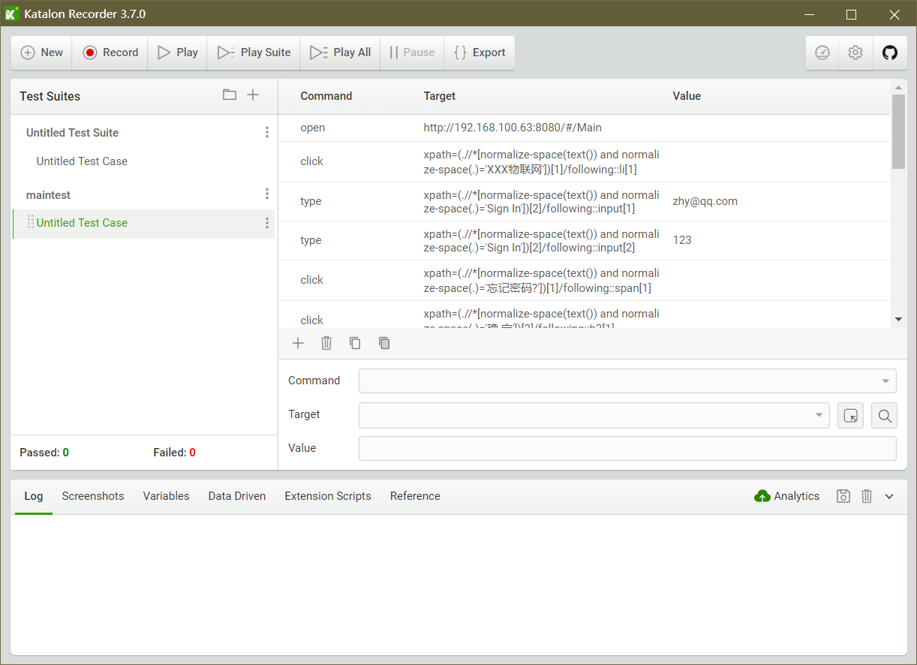

创建新的test suites测试脚本文件

### 2.启动应用脚本编写

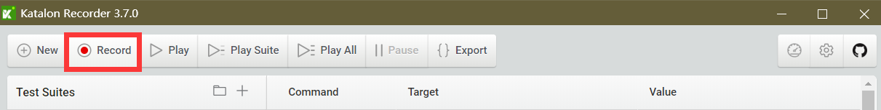

单击Record按钮，开始网页的录制

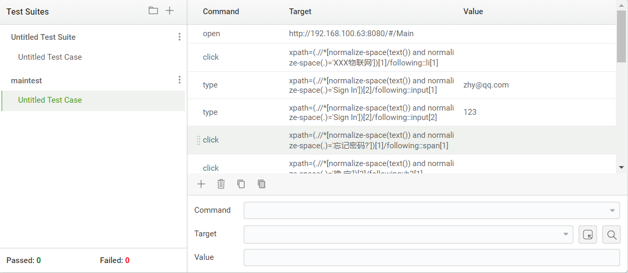

### 3.录制功能

点击录制开始，web录制

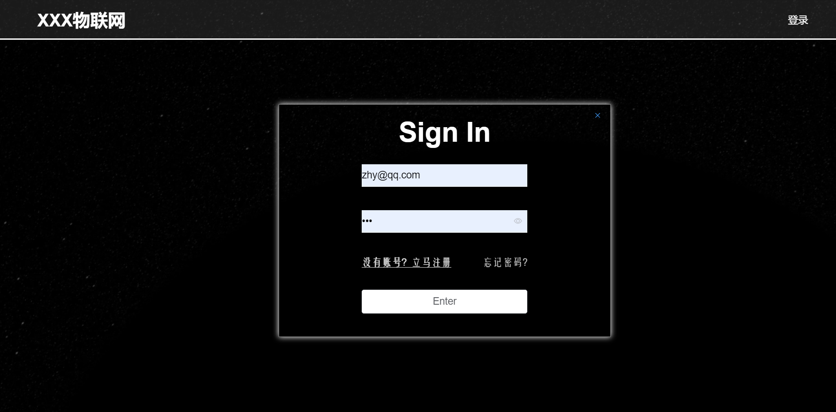

Katalon Recorder自动开始chrome网页。



生成python2（webdriver+Unittest）脚本：

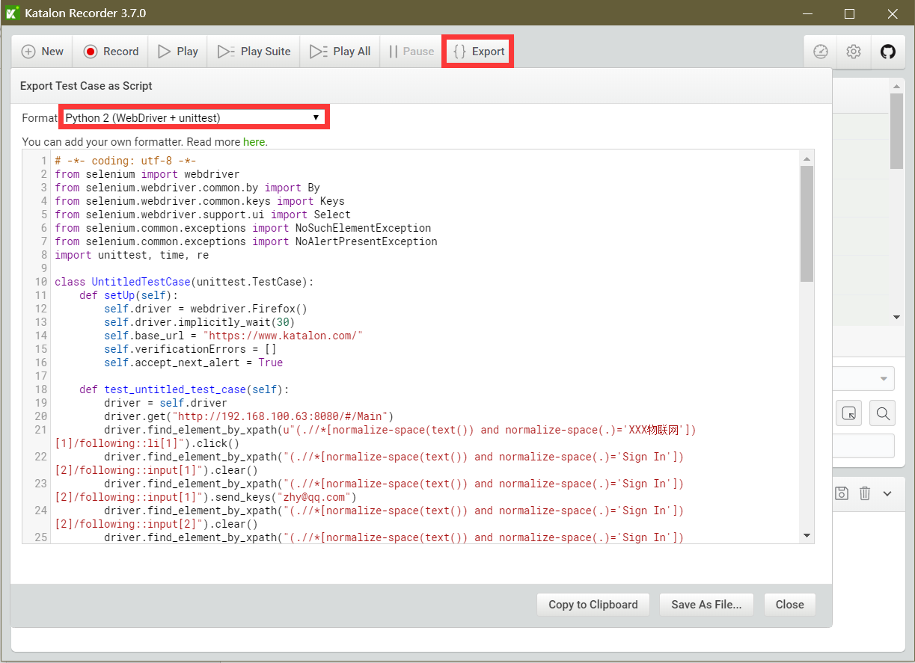

# -*- coding: utf-8 -*-

from selenium import webdriver

from selenium.webdriver.common.by import By

from selenium.webdriver.common.keys import Keys

from selenium.webdriver.support.ui import Select

from selenium.common.exceptions import NoSuchElementException

from selenium.common.exceptions import NoAlertPresentException

import unittest, time, re

class UntitledTestCase(unittest.TestCase):

def setUp(self):

self.driver = webdriver.Firefox()

self.driver.implicitly_wait(30)

self.base_url = "https://www.katalon.com/"

self.verificationErrors = []

self.accept_next_alert = True

def test_untitled_test_case(self):

driver = self.driver

driver.get("http://192.168.100.63:8080/#/Main")

driver.find_element_by_xpath(u"(.//*[normalize-space(text()) and normalize-space(.)='XXX物联网'])[1]/following::li[1]").click()

driver.find_element_by_xpath("(.//*[normalize-space(text()) and normalize-space(.)='Sign In'])[2]/following::input[1]").clear()

driver.find_element_by_xpath("(.//*[normalize-space(text()) and normalize-space(.)='Sign In'])[2]/following::input[1]").send_keys("zhy@qq.com")

driver.find_element_by_xpath("(.//*[normalize-space(text()) and normalize-space(.)='Sign In'])[2]/following::input[2]").clear()

driver.find_element_by_xpath("(.//*[normalize-space(text()) and normalize-space(.)='Sign In'])[2]/following::input[2]").send_keys("123")

driver.find_element_by_xpath(u"(.//*[normalize-space(text()) and normalize-space(.)='忘记密码?'])[1]/following::span[1]").click()

driver.find_element_by_xpath(u"(.//*[normalize-space(text()) and normalize-space(.)='确 定'])[2]/following::h2[1]").click()

driver.find_element_by_xpath(u"(.//*[normalize-space(text()) and normalize-space(.)='退出登录'])[1]/following::span[2]").click()

driver.find_element_by_xpath("//div[@id='ManageLeftPart']/div/ul/li[3]/span").click()

driver.find_element_by_xpath("//div[@id='ManageLeftPart']/div/ul/li[4]/span").click()

driver.find_element_by_xpath("//div[@id='ManageLeftPart']/div/ul/li[5]/span").click()

driver.find_element_by_xpath("//div[@id='ManageLeftPart']/div/ul/li[6]/span").click()

driver.find_element_by_xpath(u"(.//*[normalize-space(text()) and normalize-space(.)='这是Page6的内容'])[1]/preceding::span[1]").click()

driver.find_element_by_xpath(u"(.//*[normalize-space(text()) and normalize-space(.)='产业中心'])[1]/following::img[1]").click()

driver.find_element_by_xpath(u"(.//*[normalize-space(text()) and normalize-space(.)='个人中心'])[1]/following::li[1]").click()

driver.find_element_by_xpath("(.//*[normalize-space(text()) and normalize-space(.)='E-mail'])[1]/following::input[1]").clear()

driver.find_element_by_xpath("(.//*[normalize-space(text()) and normalize-space(.)='E-mail'])[1]/following::input[1]").send_keys("zhy@qq.com")

driver.find_element_by_xpath("(.//*[normalize-space(text()) and normalize-space(.)='Password'])[1]/following::input[1]").clear()

driver.find_element_by_xpath("(.//*[normalize-space(text()) and normalize-space(.)='Password'])[1]/following::input[1]").send_keys("123")

driver.find_element_by_xpath(u"(.//*[normalize-space(text()) and normalize-space(.)='验证码'])[1]/following::input[1]").clear()

driver.find_element_by_xpath(u"(.//*[normalize-space(text()) and normalize-space(.)='验证码'])[1]/following::input[1]").send_keys("zhy@qq.com")

driver.find_element_by_xpath("(.//*[normalize-space(text()) and normalize-space(.)='Password1'])[1]/following::input[1]").clear()

driver.find_element_by_xpath("(.//*[normalize-space(text()) and normalize-space(.)='Password1'])[1]/following::input[1]").send_keys("123")

def is_element_present(self, how, what):

try: self.driver.find_element(by=how, value=what)

except NoSuchElementException as e: return False

return True

def is_alert_present(self):

try: self.driver.switch_to_alert()

except NoAlertPresentException as e: return False

return True

def close_alert_and_get_its_text(self):

try:

alert = self.driver.switch_to_alert()

alert_text = alert.text

if self.accept_next_alert:

alert.accept()

else:

alert.dismiss()

return alert_text

finally: self.accept_next_alert = True

def tearDown(self):

self.driver.quit()

self.assertEqual([], self.verificationErrors)

if __name__ == "__main__":

unittest.main()

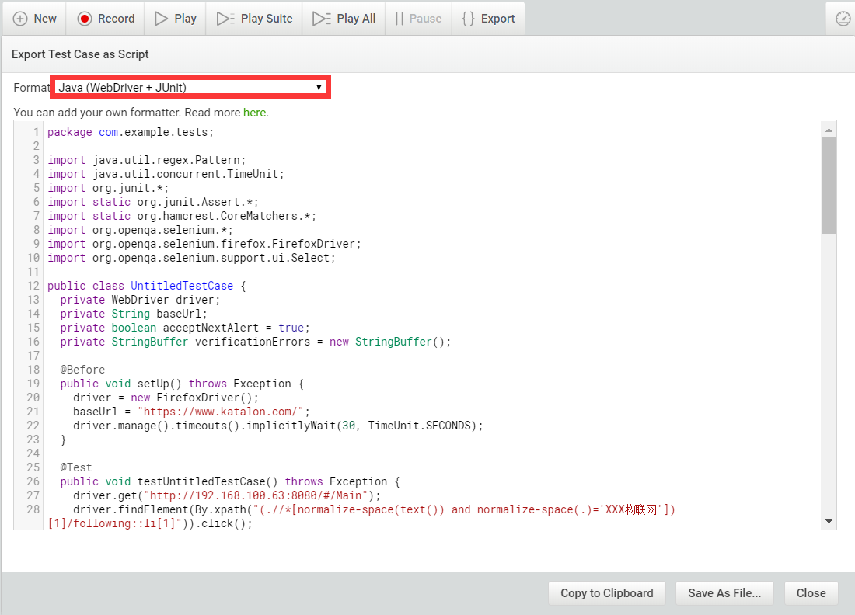

启用Katalon Recorder脚本转置成java：

**import** java.util.regex.Pattern;  
**import** java.util.concurrent.TimeUnit;  
**import** org.junit.*;  
**import static** org.junit.Assert.*;  
**import static** org.hamcrest.CoreMatchers.*;  
**import** org.openqa.selenium.*;  
**import** org.openqa.selenium.chrome.ChromeDriver;  
**import** org.openqa.selenium.firefox.FirefoxDriver;  
**import** org.openqa.selenium.support.ui.Select;  
  
**public class** maintest {  
 **private** WebDriver **driver**;  
 **private** String **baseUrl**;  
 **private boolean acceptNextAlert** = **true**;  
 **private** StringBuffer **verificationErrors** = **new** StringBuffer();  
  
 @Before  
 **public void** setUp() **throws** Exception {  
 System.*setProperty*(**"webdriver.chrome.driver"**,**"D:\\IDEA_pro\\233\\src\\chromedriver.exe"**);  
 **driver** = **new** ChromeDriver();  
 **baseUrl** = **"https://www.katalon.com/"**;  
 **driver**.manage().timeouts().implicitlyWait(30, TimeUnit.***SECONDS***);  
 }  
  
 @Test  
 **public void** testUntitledTestCase() **throws** Exception {  
 **driver**.get(**"http://192.168.100.63:8080/#/Main"**);  
 **driver**.findElement(By.*xpath*(**"(.//*[normalize-space(text()) and normalize-space(.)='XXX物联网'])[1]/following::li[1]"**)).click();  
 **driver**.findElement(By.*xpath*(**"(.//*[normalize-space(text()) and normalize-space(.)='Sign In'])[2]/following::input[1]"**)).clear();  
 **driver**.findElement(By.*xpath*(**"(.//*[normalize-space(text()) and normalize-space(.)='Sign In'])[2]/following::input[1]"**)).sendKeys(**"zhy@qq.com"**);  
 **driver**.findElement(By.*xpath*(**"(.//*[normalize-space(text()) and normalize-space(.)='Sign In'])[2]/following::input[2]"**)).clear();  
 **driver**.findElement(By.*xpath*(**"(.//*[normalize-space(text()) and normalize-space(.)='Sign In'])[2]/following::input[2]"**)).sendKeys(**"123"**);  
 **driver**.findElement(By.*xpath*(**"(.//*[normalize-space(text()) and normalize-space(.)='忘记密码?'])[1]/following::button[1]"**)).click();  
 **driver**.findElement(By.*xpath*(**"(.//*[normalize-space(text()) and normalize-space(.)='确 定'])[2]/following::h2[1]"**)).click();  
 **driver**.findElement(By.*xpath*(**"(.//*[normalize-space(text()) and normalize-space(.)='鲸鱼养殖'])[1]/following::span[1]"**)).click();  
 **driver**.findElement(By.*xpath*(**"(.//*[normalize-space(text()) and normalize-space(.)='添加产品'])[1]/following::i[1]"**)).click();  
 **driver**.findElement(By.*xpath*(**"(.//*[normalize-space(text()) and normalize-space(.)='退出登录'])[1]/following::span[2]"**)).click();  
 **driver**.findElement(By.*xpath*(**"(.//*[normalize-space(text()) and normalize-space(.)='采集单元数量（个）'])[1]/following::span[1]"**)).click();  
 **driver**.findElement(By.*xpath*(**"(.//*[normalize-space(text()) and normalize-space(.)='添加采集单元'])[1]/following::i[1]"**)).click();  
 **driver**.findElement(By.*xpath*(**"//div[@id='ManageLeftPart']/div/ul/li[3]/span"**)).click();  
 **driver**.findElement(By.*xpath*(**"(.//*[normalize-space(text()) and normalize-space(.)='这是Page3的内容'])[1]/following::input[1]"**)).click();  
 **driver**.findElement(By.*xpath*(**"(.//*[normalize-space(text()) and normalize-space(.)='六'])[1]/following::span[10]"**)).click();  
 **driver**.findElement(By.*xpath*(**"(.//*[normalize-space(text()) and normalize-space(.)='六'])[1]/following::span[10]"**)).click();  
 **driver**.findElement(By.*xpath*(**"(.//*[normalize-space(text()) and normalize-space(.)='确认'])[1]/following::input[2]"**)).click();  
 **driver**.findElement(By.*xpath*(**"(.//*[normalize-space(text()) and normalize-space(.)='确认'])[1]/following::li[86]"**)).click();  
 **driver**.findElement(By.*xpath*(**"(.//*[normalize-space(text()) and normalize-space(.)='取消'])[1]/following::button[1]"**)).click();  
 **driver**.findElement(By.*xpath*(**"(.//*[normalize-space(text()) and normalize-space(.)='确定'])[1]/following::input[1]"**)).click();  
 **driver**.findElement(By.*xpath*(**"(.//*[normalize-space(text()) and normalize-space(.)='确定'])[1]/following::input[2]"**)).click();  
 **driver**.findElement(By.*xpath*(**"(.//*[normalize-space(text()) and normalize-space(.)='取消'])[2]/following::button[1]"**)).click();  
 **driver**.findElement(By.*xpath*(**"(.//*[normalize-space(text()) and normalize-space(.)='清空'])[1]/following::span[1]"**)).click();  
 **driver**.findElement(By.*xpath*(**"(.//*[normalize-space(text()) and normalize-space(.)='-'])[1]/following::i[2]"**)).click();  
 **driver**.findElement(By.*xpath*(**"(.//*[normalize-space(text()) and normalize-space(.)='蓝鲸养殖_1'])[1]/following::span[1]"**)).click();  
 **driver**.findElement(By.*xpath*(**"(.//*[normalize-space(text()) and normalize-space(.)='-'])[1]/following::span[3]"**)).click();  
 **driver**.findElement(By.*xpath*(**"//div[@id='ManageLeftPart']/div/ul/li[4]/span"**)).click();  
 **driver**.findElement(By.*xpath*(**"(.//*[normalize-space(text()) and normalize-space(.)='这是Page4的内容'])[1]/following::i[1]"**)).click();  
 **driver**.findElement(By.*xpath*(**"(.//*[normalize-space(text()) and normalize-space(.)='蓝鲸养殖_1'])[1]/following::span[1]"**)).click();  
 **driver**.findElement(By.*xpath*(**"(.//*[normalize-space(text()) and normalize-space(.)='这是Page4的内容'])[1]/following::span[3]"**)).click();  
 **driver**.findElement(By.*xpath*(**"//div[@id='ManageLeftPart']/div/ul/li[5]/span"**)).click();  
 **driver**.findElement(By.*xpath*(**"//div[@id='ManageLeftPart']/div/ul/li[6]/span"**)).click();  
 **driver**.findElement(By.*xpath*(**"(.//*[normalize-space(text()) and normalize-space(.)='这是Page6的内容'])[1]/preceding::span[1]"**)).click();  
 **driver**.findElement(By.*xpath*(**"(.//*[normalize-space(text()) and normalize-space(.)='产业中心'])[1]/following::img[1]"**)).click();  
 **driver**.findElement(By.*xpath*(**"(.//*[normalize-space(text()) and normalize-space(.)='个人中心'])[1]/following::li[1]"**)).click();  
 **driver**.findElement(By.*xpath*(**"(.//*[normalize-space(text()) and normalize-space(.)='E-mail'])[1]/following::input[1]"**)).clear();  
 **driver**.findElement(By.*xpath*(**"(.//*[normalize-space(text()) and normalize-space(.)='E-mail'])[1]/following::input[1]"**)).sendKeys(**"zhy@qq.com"**);  
 **driver**.findElement(By.*xpath*(**"(.//*[normalize-space(text()) and normalize-space(.)='Password'])[1]/following::input[1]"**)).clear();  
 **driver**.findElement(By.*xpath*(**"(.//*[normalize-space(text()) and normalize-space(.)='Password'])[1]/following::input[1]"**)).sendKeys(**"123"**);  
 **driver**.findElement(By.*xpath*(**"(.//*[normalize-space(text()) and normalize-space(.)='验证码'])[1]/following::input[1]"**)).clear();  
 **driver**.findElement(By.*xpath*(**"(.//*[normalize-space(text()) and normalize-space(.)='验证码'])[1]/following::input[1]"**)).sendKeys(**"zhy@qq.com"**);  
 **driver**.findElement(By.*xpath*(**"(.//*[normalize-space(text()) and normalize-space(.)='Password1'])[1]/following::input[1]"**)).clear();  
 **driver**.findElement(By.*xpath*(**"(.//*[normalize-space(text()) and normalize-space(.)='Password1'])[1]/following::input[1]"**)).sendKeys(**"123"**);  
 }  
  
 @After  
 **public void** tearDown() **throws** Exception {  
 **driver**.quit();  
 String verificationErrorString = **verificationErrors**.toString();  
 **if** (!**""**.equals(verificationErrorString)) {  
 *fail*(verificationErrorString);  
 }  
 }  
  
 **private boolean** isElementPresent(By by) {  
 **try** {  
 **driver**.findElement(by);  
 **return true**;  
 } **catch** (NoSuchElementException e) {  
 **return false**;  
 }  
 }  
  
 **private boolean** isAlertPresent() {  
 **try** {  
 **driver**.switchTo().alert();  
 **return true**;  
 } **catch** (NoAlertPresentException e) {  
 **return false**;  
 }  
 }  
  
 **private** String closeAlertAndGetItsText() {  
 **try** {  
 Alert alert = **driver**.switchTo().alert();  
 String alertText = alert.getText();  
 **if** (**acceptNextAlert**) {  
 alert.accept();  
 } **else** {  
 alert.dismiss();  
 }  
 **return** alertText;  
 } **finally** {  
 **acceptNextAlert** = **true**;  
 }  
 }  
}

# 三、 自动化测试实例三

## 3.1.测试实例特征

本测试实例是包括对报表的维护功能操作，包括新建报表，设计报表（拖放分组，拖放指标等）。并对成功和异常操作分别记录操作日志和异常日志。

## 3.2 测试过程

### 1．装载应用

略。（与实例一方法实现类似，请参阅）

### 2．启动应用脚本编写

略。（与实例一方法实现类似，请参阅）

### 3．录制功能

**生成python2（webdriver+Unittest）脚本：**

# -*- coding: utf-8 -*-

from selenium import webdriver

from selenium.webdriver.common.by import By

from selenium.webdriver.common.keys import Keys

from selenium.webdriver.support.ui import Select

from selenium.common.exceptions import NoSuchElementException

from selenium.common.exceptions import NoAlertPresentException

import unittest, time, re

class UntitledTestCase(unittest.TestCase):

def setUp(self):

self.driver = webdriver.Firefox()

self.driver.implicitly_wait(30)

self.base_url = "https://www.katalon.com/"

self.verificationErrors = []

self.accept_next_alert = True

def test_untitled_test_case(self):

driver = self.driver

driver.get("http://192.168.100.63:8080/#/Home/Manage")

driver.find_element_by_xpath(u"(.//*[normalize-space(text()) and normalize-space(.)='退出登录'])[1]/following::span[2]").click()

driver.find_element_by_xpath("//div[@id='ManageLeftPart']/div/ul/li[3]/span").click()

driver.find_element_by_xpath("//div[@id='ManageLeftPart']/div/ul/li[4]/span").click()

driver.find_element_by_xpath("//div[@id='ManageLeftPart']/div/ul/li[5]/span").click()

driver.find_element_by_xpath("//div[@id='ManageLeftPart']/div/ul/li[6]/span").click()

driver.find_element_by_xpath("//div[@id='ManageLeftPart']/div/ul/li[7]/span").click()

driver.find_element_by_xpath(u"(.//*[normalize-space(text()) and normalize-space(.)='这是Page8的内容'])[1]/preceding::span[1]").click()

driver.find_element_by_xpath(u"(.//*[normalize-space(text()) and normalize-space(.)='退出登录'])[1]/following::span[1]").click()

driver.find_element_by_xpath(u"(.//*[normalize-space(text()) and normalize-space(.)='退出登录'])[1]/following::span[2]").click()

driver.find_element_by_xpath(u"(.//*[normalize-space(text()) and normalize-space(.)='立即添加'])[1]/following::div[2]").click()

driver.find_element_by_xpath("(.//*[normalize-space(text()) and normalize-space(.)='first'])[3]/following::span[1]").click()

driver.find_element_by_xpath(u"(.//*[normalize-space(text()) and normalize-space(.)='操作'])[1]/following::i[1]").click()

driver.find_element_by_xpath(u"(.//*[normalize-space(text()) and normalize-space(.)='编辑/阈值设置'])[1]/preceding::span[1]").click()

driver.find_element_by_xpath(u"(.//*[normalize-space(text()) and normalize-space(.)='传感器详情'])[1]/following::i[1]").click()

driver.find_element_by_xpath(u"(.//*[normalize-space(text()) and normalize-space(.)='删除'])[2]/following::span[2]").click()

driver.find_element_by_xpath(u"(.//*[normalize-space(text()) and normalize-space(.)='传感器详情'])[1]/following::i[1]").click()

driver.find_element_by_xpath(u"(.//*[normalize-space(text()) and normalize-space(.)='删除'])[3]/following::span[2]").click()

driver.find_element_by_xpath(u"(.//*[normalize-space(text()) and normalize-space(.)='传感器详情'])[1]/following::i[1]").click()

driver.find_element_by_xpath(u"(.//*[normalize-space(text()) and normalize-space(.)='删除'])[4]/following::span[2]").click()

driver.find_element_by_xpath(u"(.//*[normalize-space(text()) and normalize-space(.)='传感器详情'])[1]/following::i[1]").click()

driver.find_element_by_xpath(u"(.//*[normalize-space(text()) and normalize-space(.)='已入网'])[1]/following::span[1]").click()

driver.find_element_by_xpath(u"(.//*[normalize-space(text()) and normalize-space(.)='这是Page4的内容'])[1]/following::i[1]").click()

driver.find_element_by_xpath(u"(.//*[normalize-space(text()) and normalize-space(.)='这是Page4的内容'])[1]/following::i[1]").click()

driver.find_element_by_xpath("//div[@id='ManageLeftPart']/div/ul/li[5]/span").click()

def is_element_present(self, how, what):

try: self.driver.find_element(by=how, value=what)

except NoSuchElementException as e: return False

return True

def is_alert_present(self):

try: self.driver.switch_to_alert()

except NoAlertPresentException as e: return False

return True

def close_alert_and_get_its_text(self):

try:

alert = self.driver.switch_to_alert()

alert_text = alert.text

if self.accept_next_alert:

alert.accept()

else:

alert.dismiss()

return alert_text

finally: self.accept_next_alert = True

def tearDown(self):

self.driver.quit()

self.assertEqual([], self.verificationErrors)

if __name__ == "__main__":

unittest.main()

**启用Katalon Recorder脚本转置成java：**

package com.example.tests;

import java.util.regex.Pattern;

import java.util.concurrent.TimeUnit;

import org.junit.*;

import static org.junit.Assert.*;

import static org.hamcrest.CoreMatchers.*;

import org.openqa.selenium.*;

import org.openqa.selenium.firefox.FirefoxDriver;

import org.openqa.selenium.support.ui.Select;

public class UntitledTestCase {

private WebDriver driver;

private String baseUrl;

private boolean acceptNextAlert = true;

private StringBuffer verificationErrors = new StringBuffer();

@Before

public void setUp() throws Exception {

/*此时生成Firefox的启动驱动，真正实验时替换为chrome驱动*/

driver = new FirefoxDriver();

baseUrl = "https://www.katalon.com/";

driver.manage().timeouts().implicitlyWait(30, TimeUnit.SECONDS);

}

@Test

public void testUntitledTestCase() throws Exception {

driver.get("http://192.168.100.63:8080/#/Home/Manage");

driver.findElement(By.xpath("(.//*[normalize-space(text()) and normalize-space(.)='退出登录'])[1]/following::span[2]")).click();

driver.findElement(By.xpath("//div[@id='ManageLeftPart']/div/ul/li[3]/span")).click();

driver.findElement(By.xpath("//div[@id='ManageLeftPart']/div/ul/li[4]/span")).click();

driver.findElement(By.xpath("//div[@id='ManageLeftPart']/div/ul/li[5]/span")).click();

driver.findElement(By.xpath("//div[@id='ManageLeftPart']/div/ul/li[6]/span")).click();

driver.findElement(By.xpath("//div[@id='ManageLeftPart']/div/ul/li[7]/span")).click();

driver.findElement(By.xpath("(.//*[normalize-space(text()) and normalize-space(.)='这是Page8的内容'])[1]/preceding::span[1]")).click();

driver.findElement(By.xpath("(.//*[normalize-space(text()) and normalize-space(.)='退出登录'])[1]/following::span[1]")).click();

driver.findElement(By.xpath("(.//*[normalize-space(text()) and normalize-space(.)='退出登录'])[1]/following::span[2]")).click();

driver.findElement(By.xpath("(.//*[normalize-space(text()) and normalize-space(.)='立即添加'])[1]/following::div[2]")).click();

driver.findElement(By.xpath("(.//*[normalize-space(text()) and normalize-space(.)='first'])[3]/following::span[1]")).click();

driver.findElement(By.xpath("(.//*[normalize-space(text()) and normalize-space(.)='操作'])[1]/following::i[1]")).click();

driver.findElement(By.xpath("(.//*[normalize-space(text()) and normalize-space(.)='编辑/阈值设置'])[1]/preceding::span[1]")).click();

driver.findElement(By.xpath("(.//*[normalize-space(text()) and normalize-space(.)='传感器详情'])[1]/following::i[1]")).click();

driver.findElement(By.xpath("(.//*[normalize-space(text()) and normalize-space(.)='删除'])[2]/following::span[2]")).click();

driver.findElement(By.xpath("(.//*[normalize-space(text()) and normalize-space(.)='传感器详情'])[1]/following::i[1]")).click();

driver.findElement(By.xpath("(.//*[normalize-space(text()) and normalize-space(.)='删除'])[3]/following::span[2]")).click();

driver.findElement(By.xpath("(.//*[normalize-space(text()) and normalize-space(.)='传感器详情'])[1]/following::i[1]")).click();

driver.findElement(By.xpath("(.//*[normalize-space(text()) and normalize-space(.)='删除'])[4]/following::span[2]")).click();

driver.findElement(By.xpath("(.//*[normalize-space(text()) and normalize-space(.)='传感器详情'])[1]/following::i[1]")).click();

driver.findElement(By.xpath("(.//*[normalize-space(text()) and normalize-space(.)='已入网'])[1]/following::span[1]")).click();

driver.findElement(By.xpath("(.//*[normalize-space(text()) and normalize-space(.)='这是Page4的内容'])[1]/following::i[1]")).click();

driver.findElement(By.xpath("(.//*[normalize-space(text()) and normalize-space(.)='这是Page4的内容'])[1]/following::i[1]")).click();

driver.findElement(By.xpath("//div[@id='ManageLeftPart']/div/ul/li[5]/span")).click();

}

@After

public void tearDown() throws Exception {

driver.quit();

String verificationErrorString = verificationErrors.toString();

if (!"".equals(verificationErrorString)) {

fail(verificationErrorString);

}

}

private boolean isElementPresent(By by) {

try {

driver.findElement(by);

return true;

} catch (NoSuchElementException e) {

return false;

}

}

private boolean isAlertPresent() {

try {

driver.switchTo().alert();

return true;

} catch (NoAlertPresentException e) {

return false;

}

}

private String closeAlertAndGetItsText() {

try {

Alert alert = driver.switchTo().alert();

String alertText = alert.getText();

if (acceptNextAlert) {

alert.accept();

} else {

alert.dismiss();

}

return alertText;

} finally {

acceptNextAlert = true;

}

}

}

# 五、测试小结

对Katalon Recorder 熟悉使用的过程中发现其功能非常丰富，虽然现在可以借荐的参阅资料还是很少，另外它有很多帮助写测试脚本的页面工具，比如python2（webDriver+unittest）、java（webDriver-backed Remote Control + JUnit）、c#（webDriver+MSTest）。KR提供的语言十分的丰富，应用场景也十分的广泛，运用熟练的话可以成为web测试的利器。

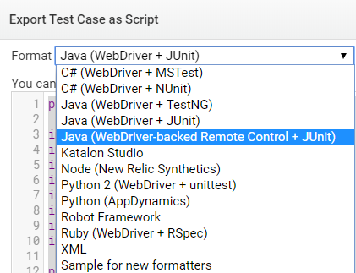

# 六、附录

https://blog.csdn.net/yangdengcheng/article/details/80265628

https://blog.csdn.net/u014285482/article/details/41631375

https://www.cnblogs.com/surewing/p/7860812.html

https://blog.csdn.net/yangdengcheng/article/details/80265628

https://blog.csdn.net/hi_sir_destroy/article/details/89639213